**Activity 13.3 - Mohammed Abdin**

**Submission Instructions:**

Your submission for this assignment should be a Word document that includes the following screenshots, each labeled for the step that the screenshot represents:

1. Provide a screenshot of the “Activity13.3” folder with a container.py file in VS Code.

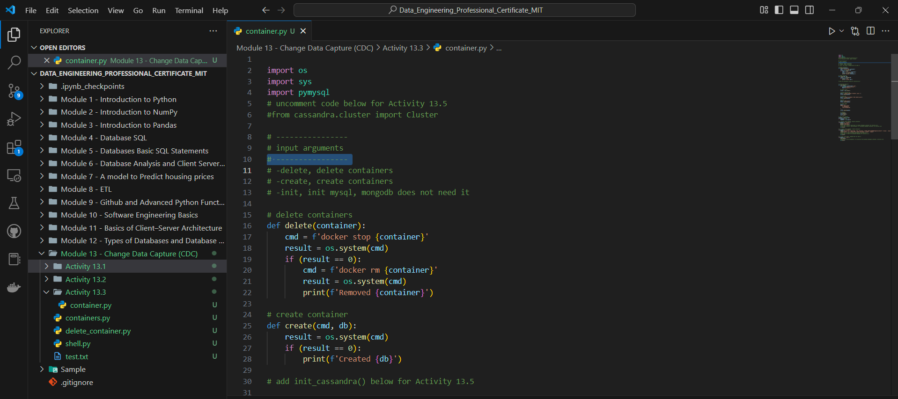

1. Provide a screenshot of the command prompt showing that you successfully executed the container.py Python program and passed -create as a parameter.

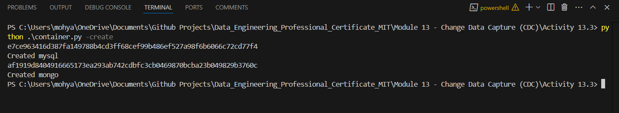

1. Provide a screenshot of your Docker desktop showing the two *containers*, MySQL and MongoDB, running.

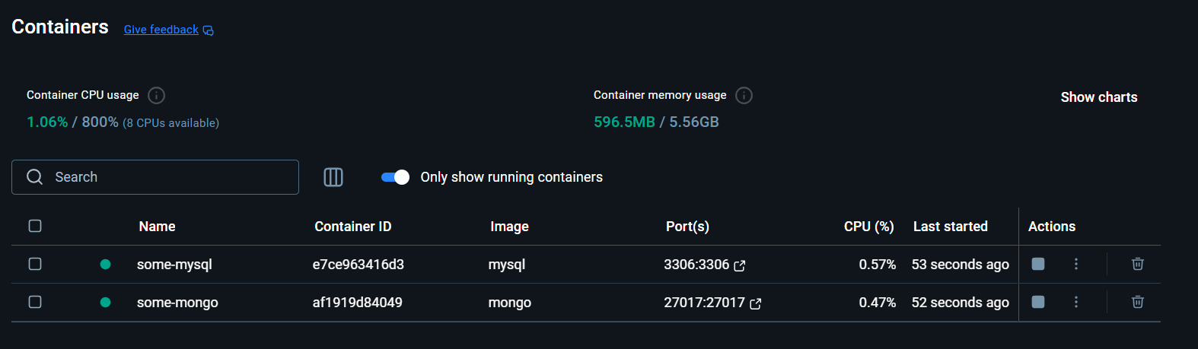

1. Provide a screenshot to show that you successfully created the mysqldb.py file.

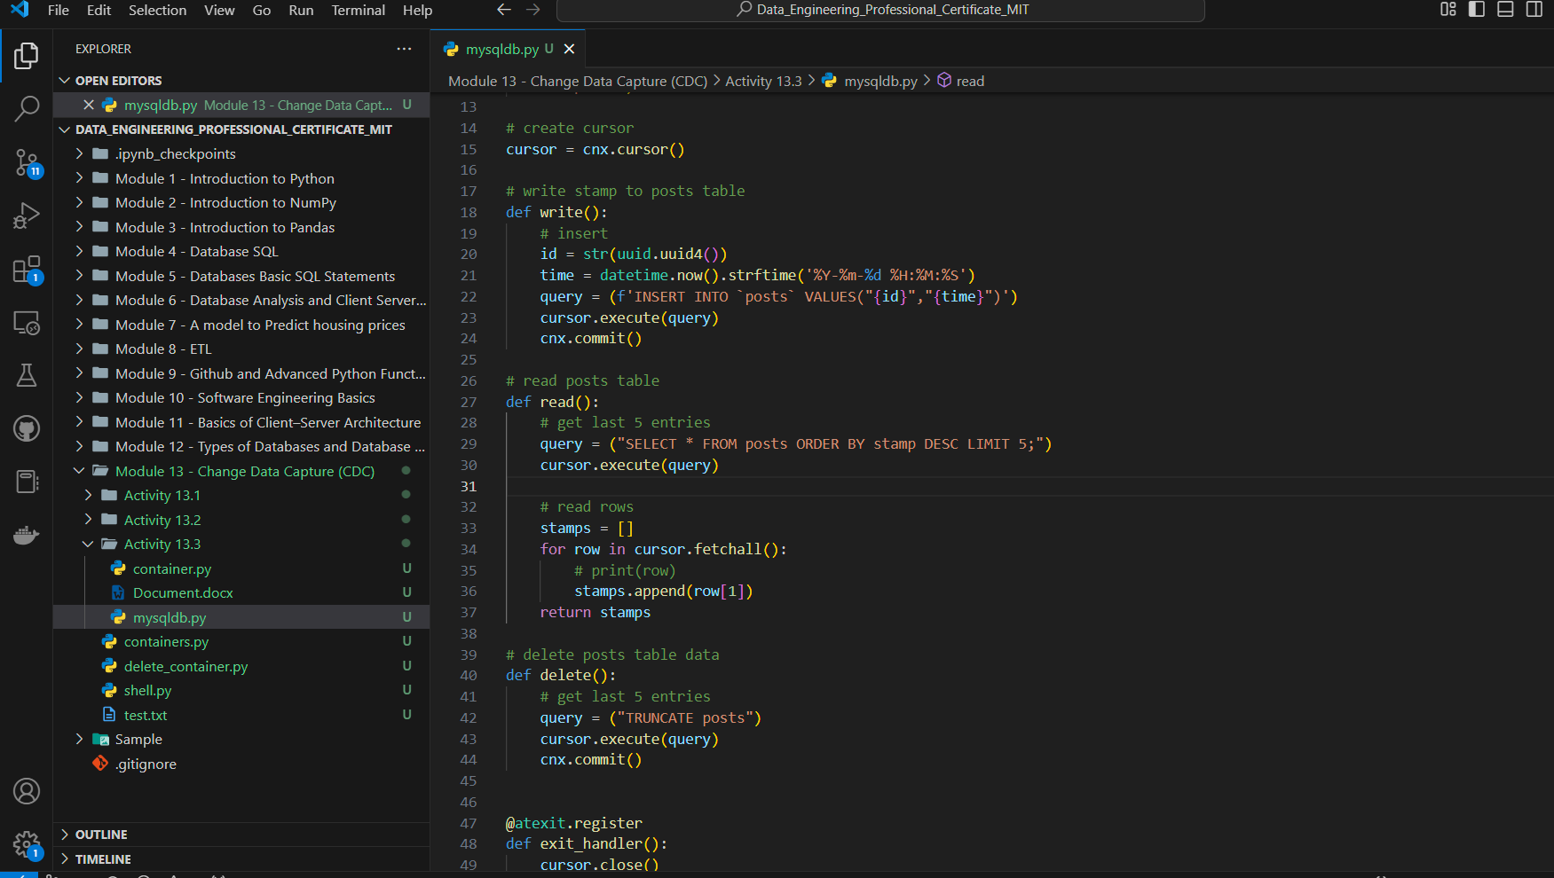

1. Provide a screenshot to show that you successfully created the mongodb.py file.

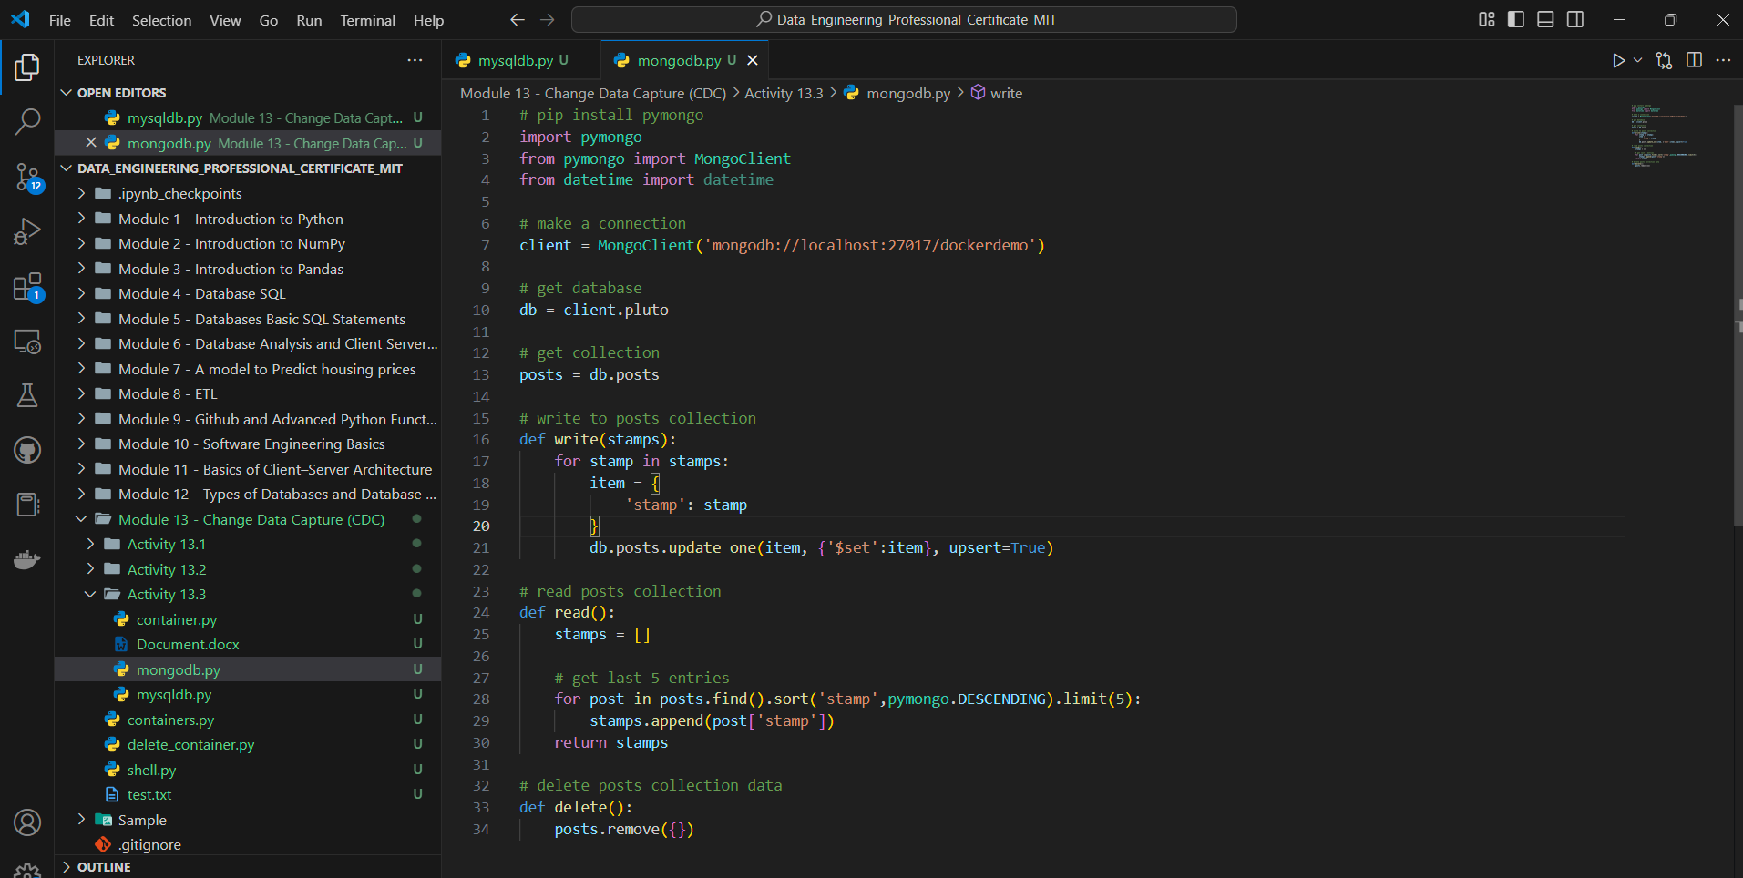

1. Provide a screenshot to show that you successfully created the scheduler.py file.

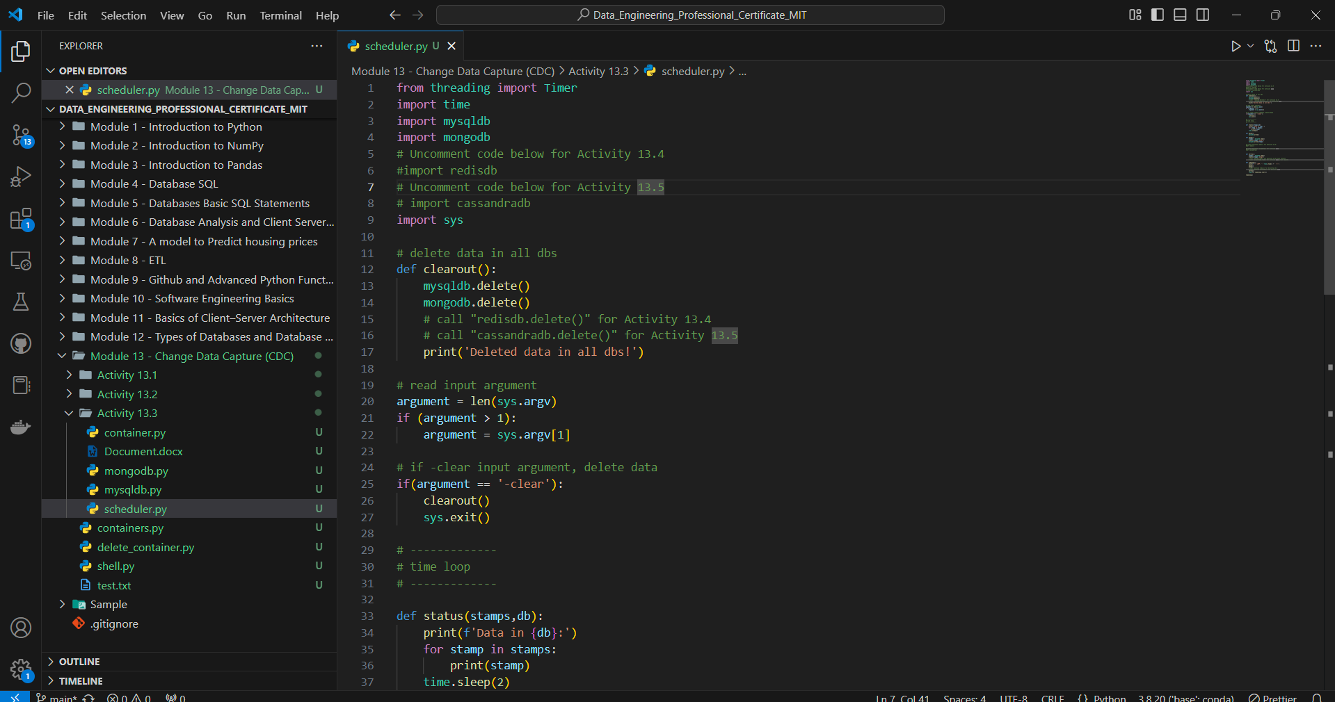

1. Provide a screenshot of the command prompt showing that you successfully executed the container.py Python program and passed -init as a parameter to initialize your databases.

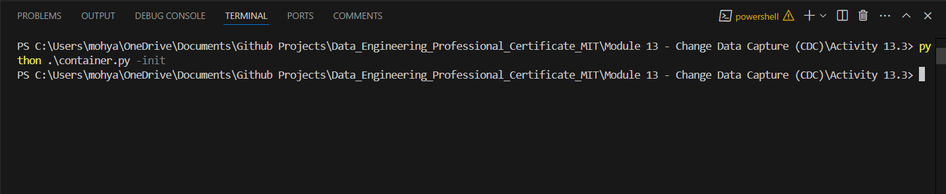

1. Provide a screenshot of your Terminal window showing the scheduler.py program running.

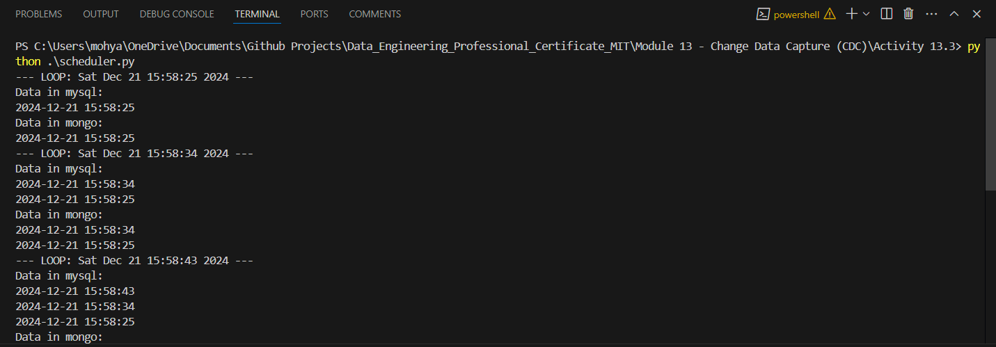

1. Provide a screenshot to show that you successfully stopped the scheduler.py program by closing the command prompt window and ran the container.py command from the command prompt passing -delete as a parameter.

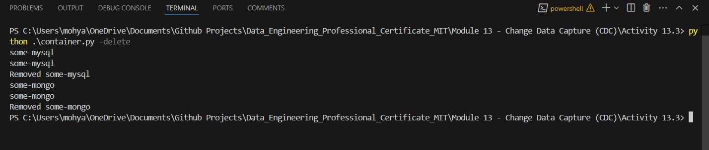

1. Provide a screenshot of the Docker desktop showing that both database *containers* have been removed.

